# **Back-to-Back: 2020 Dodge Dynasty Champion – Greg Perry**

Congratulations to Greg Perry for winning his second straight Dodge Dynasty Worlds Championship! Breaking an incredible streak of 8 different people winning the past 8 championships, Twitch also becomes the first back-to-back winner since Jeffrey Ronaldinho Pohlmann in 2009 & 2010. Derrick Henry proved last year was no fluke by posting another huge season, and Davante Adams blasted to ‘best receiver on the planet’ status (with some opposition from the greater KC area). Lamar Jackson kinda sucked this year, but really turned it on in the playoffs when he wasn’t racing to the bathroom. Aided by other clutch acquisitions like Antonio Gibson, Myles Gaskin, Corey Davis, etc, Twitch’s team brushed off the early loss of Saquon Barkley & once again took home the title, defeating Dave 121.1-84.5. Congrats Twitch!

Runner-up Dave Nickelsen finished 2nd overall in pts scored this year, but had to take the long road through the playoffs after just missing out on the division crown behind newcomer Jason Bratten. The 2018 winner has now appeared in five Dynasty championship games, a new record. Jason, meanwhile, inherited an 0-2 Brian squad and merely went 9-2 the rest of the year while picking up the Dynasty Survivor victory along the way. Led by James “Smoke” Robinson and Patrick “Mirrors” Mahomes, Smoke + Mirrors was one of two teams to come up just short in the semifinals despite breaking triple digits (along with Mike Kerkel). And kudos to Yinzer team-supporting Jeremiah Yugulis, who despite this flaw has reached the Dynasty playoffs for the 7th consecutive season, the longest active streak in the league.

As for my team, it finished: 1st overall in scoring again for a record 5th time in the league’s 13-year history, top two for the 7th time (& 4th consecutive year), top three for the 9th time, and registered the 2nd highest points total ever at 1415.3 pts (trailing only my own record of 1466 in 2018). End result: bounced out of the playoffs once again. Still sitting on 0 titles. Lather, rinse, repeat.

Thank you all, I appreciate everyone’s flexibility during this crazy & unprecedented season. I hope to see all of you again next year, this time hopefully in person at next year’s Dynasty draft (held Saturday evening of Labor Day weekend as always). Thanks again everybody, have a Happy New Year!

# **2020 Dodge Dynasty Awards**

**Dodge Dynasty MVP**

Winner: Dalvin Cook – Jeremiah

Runners-up: Alvin Kamara – George; Derrick Henry – Twitch; Davante Adams – Twitch; Tyreek Hill – Kerkel; Travis Kelce – Dan; Josh Allen – Kerkel; Patrick Mahomes – Jason

**Playoff MVP**

Winners: David Montgomery – Dave; Davante Adams – Twitch

Runners-up: Lamar Jackson – Twitch; DeAndre Hopkins – Dave; Josh Allen – Kerkel; Darren Waller – Jason

**Pickup of the Year**

Winner: James Robinson – Jason

Runners-up: A.J. Brown* – Dave; Mike Davis – Jay; Justin Herbert – Dave; Corey Davis – Twitch; Myles Gaskin – Twitch; Brandon Aiyuk – Meat (traded to George); Chase Claypool – Jeremiah

**Sleeper of the Year**

Playing for the team that drafted them

Winner: Justin Jefferson – Dave

Runners-up: Darren Waller – Jason; Josh Allen – Kerkel; Ronald Jones – Jay

**Breakout Player of the Year**

Non-Rookie

Winner: Josh Allen – Kerkel

Runners-up: Calvin Ridley – Dan; DK Metcalf – Jeremiah; David Montgomery – Dave; Kyler Murray – George; A.J. Brown – Dave; Darren Waller – Jason

**Rookie of the Year**

Winner: James Robinson – Jason

Runners-up: Jonathan Taylor – Dan; Justin Jefferson – Dave; Antonio Gibson – Twitch; Justin Herbert – Dave; D’Andre Swift – Jason; CeeDee Lamb – George

**Dodge Dynasty Owner of the Year**

Winner: Jason Bratten

Runners-up: Dave Nickelsen, Greg Perry

**Bust of the Year**

Non-Injury

Winner: Ezekiel Elliott – Kerkel

Runner-up: Clyde Edwards-Helaire – Meat

**Comeback Player of the Year**

Winner: Adam Thielen – Meat

**Didn’t Really Come Back Player of the Year**

Winner: A.J. Green

**Larry Johnson Non-Season Ending, Season Ending Injury Award**

Winner: Joe Mixon – George

Runners-up: Kenny Golladay – Dan; Christian McCaffrey – Jay; Michael Thomas – Meat

**Winner of Dynasty Survivor / Eliminator / Not Finish Last in Any Given Week Thingy**

Winner: Jason Bratten

Runner-up: Matt Robson

**Quarterback Most Likely to Invoke Tiny Cartoon Scampering Noises Every Time He Runs**

Winner: Kyler Murray – George

**Most Touchdown Receptions This Season by Wide Receivers Named Michael Thomas**

Winner: Michael Thomas – Cincinnati Bengals (1)

Runner-up: Michael Thomas – New Orleans Saints (0)

**Star NFL Player Out for the Season but Still Appearing on Every Other Commercial**

Winner: Saquon Barkley - Twitch

Runners-up: Dak Prescott – Dave; Christian McCaffrey – Jay

**Greatest Insurance Company Commercials That Feature NFL Players**

Winner: Amazing Progressive Insurance Ads featuring Baker Mayfield

Distant Runner-up: Lame State Farm Ads with Rodgers and Mahomes or whatever

**Most Likely to Tie the NFL Single Game Rushing Touchdown Record After I’ve Already Been Eliminated**

Winner: Alvin Kamara – George

**‘Let Russ Cook but only for the 1st half of the season, then Let Russ Order Out’ Award**

Winner: Russel Wilson – Steve

**Things I Was Most Wrong About This Year**

Winner: Saying “See you next month!” to coworkers in mid-March when the pandemic hit (we still have not been allowed back)

Runners-up: Thinking Josh Allen would never be very accurate; Thinking the Browns would be organizationally competent enough not to blow it against the Jets

**Future Cleveland Browns-Related Fantasy Team Name Ideas**

Winner: Unmasked Recovery Hot Tubbing

Runner-up: Padlocked Visitor Bathrooms

# **Perfect Lineups**

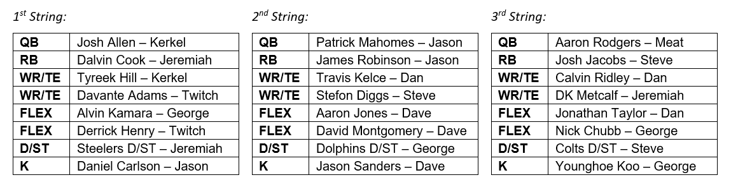

# **Next Year’s Draft Order**

Draft order for every round (excluding any 1st round comp picks)

1. Jay
2. Steve
3. Dan
4. Meat *
5. Jeremiah
6. George
7. Kerkel
8. Jason
9. Dave
10. World Champion Twitch

* Meat’s 1st round pick traded to George

# **2020 Adjusted Total Points (used for Non-Playoff Draft Order)**

